Day2

# DIAGRAMS



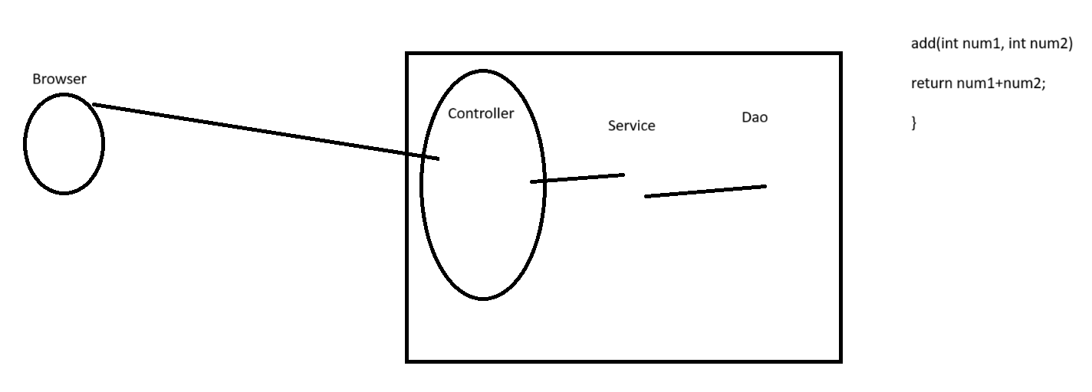

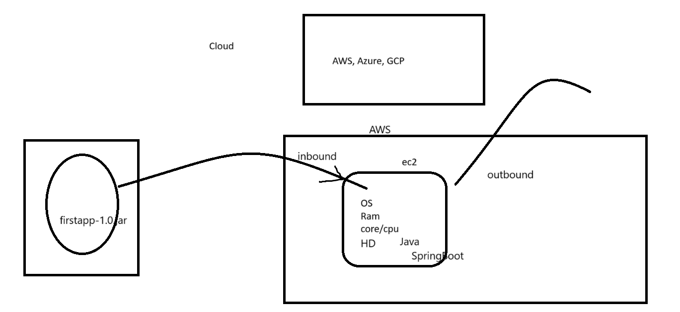

# LIVE NOTES

We start sharp at 10:00AM.

See you in few minutes.

PRACTICE DAILY!

MASSIVE DAILY EFFORTS NEEDED TO GROW & CRACK INTERVIEW.

Daily, completed it daily..

3 tasks..

Week1

mon-fri: LIVE 2/3hrs.

10AM - 12, 12:30, 1

3hrs complete task

6-7hrs of time.

Don't behave like student

Working professional

We are not going to solve any of your errors or problems..

How can you solve your own problems..

"POWER OF INTERNET"

5times.. 3-4hrs..

Your growth...

10-12-15

.YOUR PROBLEM SOLVING SKILLS HAS TO MANDATORY IMPROVE.

Week1

PIP - remove from company.

1st SpringBoot application.

start.spring.io

zip & imported in IDE

maven goal: clean spring-boot:run

http://localhost:8080

8080 - default port for springboot application.

server is running 1st time. And you are trying to start it again.

change the port???

8081

I want to start my springboot application on port 8081, what should I do....

add functional, make into an API which will be access across internet.

Layered application

Controller - entry point of the project, basic validation

- Service - Business logic

- DAO - Database logic

use packaging

<base package>.controller

com.mycomp.firstapp.controller

<base package>.service

.dao

System.out.println("Incoming values are"

+ "||num1:" + num1 + "|num2:" + num2);

the java class that we created, we want to make controller of spring boot application...

the add method expose as an API so we can invoke it from browser

IDE shortcut

ctrl + shift + o => import

f3 => get you inside class / method definition

ctrl + d => deletes

rt click => source => generate toString

Install

Postman - API testing

+ Collection

API:

endpoint/url

Req

Res

we changed code, but we had to stop existing system & restart it..

maven devtool => any changes made will be automatically reflected

maven devtools dependency

pom.xml

whenever you modify pom.xml, need to

clean spring-boot:run

Cloud based infra:

Aws, Azure, GCP,

AWS - 1year free trial

https://aws.amazon.com/console/

1. Create AWS account & login

2. Choose region, Mumbai ap-south-1

3. We will use AWS EC2 service for running java springboot application

4. Create Ec2

EC2 => Launch Instances

Linux/Unix/RedHat

5. Amazon Linux 2 - free tier

6. 1CPU - 1GB RAM - free tier

7. Securly connect to EC2 - RSA .pem

D:\ctdata\aws\sep24ct-server-key-pair.pem

8. Continue defaults

9. Launch instance

Build & Deploy

1. clean spring-boot:run

@SpringBootApplication

FirstappApplication

main

SpringApplication.run(FirstappApplication.class, args);

javac

java

---

As executable jar files.

Another approach for starting a springboot application

java -jar filename.jar

Build & Deploy

Build "clean package"

1. Compile the project code

2. Build a jar file

artifact: the output of your project when you do clean package

clean package

D:\ctws\sep24ct\firstapp\target\firstapp-1.0.jar

Deploy

3. Copy this jar file into AWS EC2 machine

4. Restart the service in EC2 machine

javac

java

java -jar firstapp-1.0.jar

java to be installed in your machine...

In Ec2 machine we need to install java.

--------

connect to ec2 machine

terminal

MobaXterm (windows)

Give me command to connect to aws ec2 machine. I have x.pem file to securely connect to AWS.

run commands to install java

copy jar file to ec2

start the spring application

Connect

ssh -i D:\\ctdata\\aws\\sep24ct-server-key-pair.pem ec2-user@13.201.20.198

17

sudo yum install java-17-amazon-corretto-17.0.10+7-1.amzn2.1.x86_64

copy jar file from local to aws

scp -i D:\\ctdata\\aws\\sep24ct-server-key-pair.pem firstapp-1.0.jar ec2-user@13.201.20.198:/home/ec2-user

supposed to know & work with basic Linux command....

ll

date

cp

mv

mkdir

vi

ssh

scp

tail

grep

when trying to deploy same jar file multiple times.. gives permission.

chmod 777 firstapp-1.0.jar

Then copy again...

Execute below command in AWS

java -jar firstapp-1.0.jar

http://13.201.20.198:8080

AWS Security Group

which ports can be access from outside.

ssh & scp - port 22

which process in running current on port 8080 or which java process is there

sudo lsof -i :8080

ps -ef | grep java

kill -9 <pid>

java -jar firstapp-1.0.jar

run this command as a background process

nohup java -jar firstapp-1.0.jar > output.log 2>&1 &

How to run in local.. and practice like AWS

in your local machine create a folder were you would deploy & restart.

build & deploy

1. clean package => jar

2. copy jar file into "deploy" (mobaxterm)

3. java -jar file.jar (mobaxterm)

4. nohup java -jar file.jar & (mobaxterm)

kill process,